**IBM ASSIGNMENT -01**

**PROGRAM**:

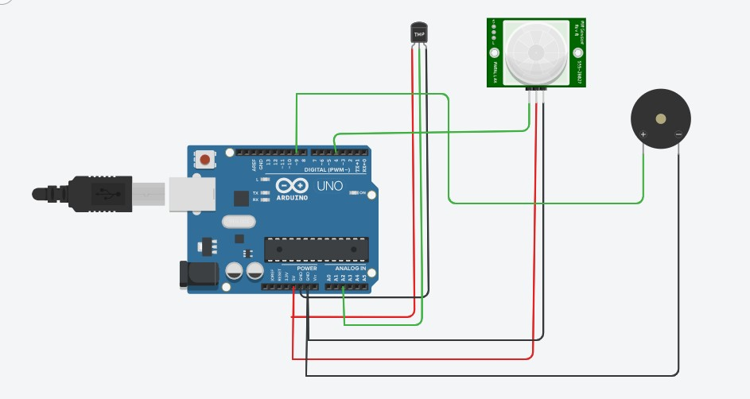

**Code**:

void setup(){

Serial.begin(9600);

pinMode(4,INPUT);

pinMode(9,OUTPUT);

}

void loop(){

double data=analogRead(A2);

double n=data/1024;

double volt=n*5;

double off=volt-0.5;

double temp=off*100;

Serial.print("Temperature Data= ");

Serial.println(temp);

int motion=digitalRead(4);

if(temp>=60)

{

tone(9,100);

delay(1000);

}

else if (motion==1)

{

tone(9,200);

delay(1000);

}

else

{

noTone(9);

delay(1000);

}

}

**OUTPUT**:

